**100285 علي محمد سويدان**

**101566 حسين مروان زهرالدين**

**103720 حبيب علي خلف**

**105553 ياسر محمد العطار**

**100796 حسين محمد قطان**

**Nb of group 73**

**INTRODUCTION:** This website is designated fora dessert shop, and is split between a user’s interface, and an admin’s one. The main items of the dessert shop called Conut Bakery are divided into 3 categories: Drinks, Chimneys, and Conuts, each with different variations and each being customizable with a set of toppings and spreads according to each customer’s personal taste. The customer can view the items, place them on order, customize them, and submit his order,in addition to leaving a feedback. Whereas an admin will be able to conduct several administrative actions, and have access to vital business-related data.

**USERS-SIDE OF THE WEBSITE**

**Login Page:**

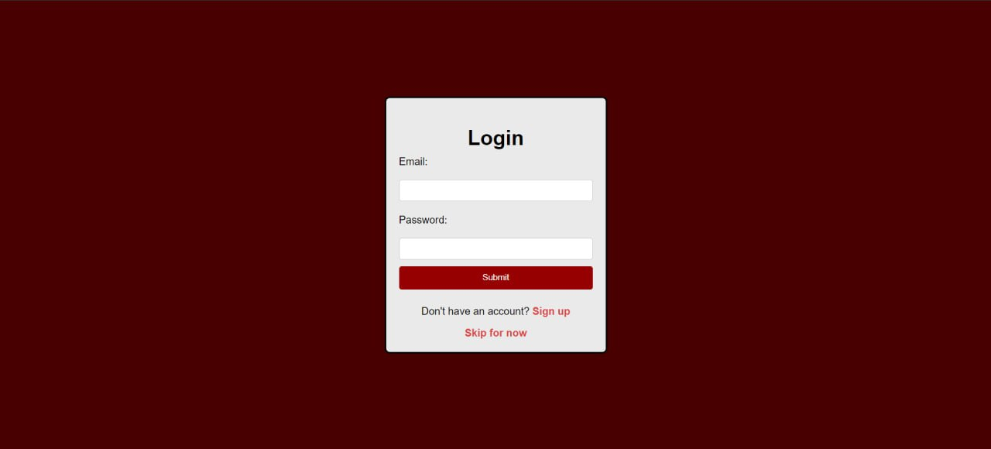

This page lets the user attempt a login, which upon the user’s entered data will be compared with that existing in the database. The user can either skip or sign up if he isn’t registered in the database. In case of skipping, the user can browse the whole user-dedicated part of the website, but will be restrained from executing any orders.

**Sign Up Page:**

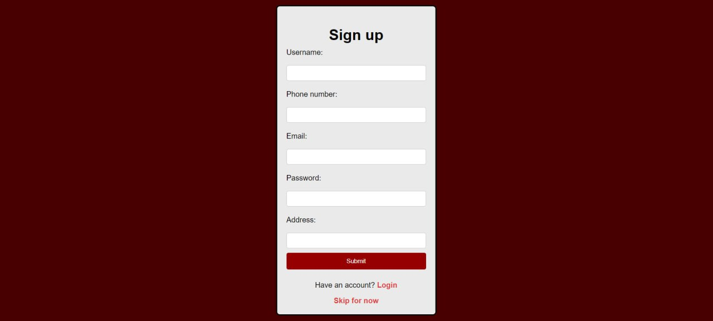

The user should insert the required data to sign up.

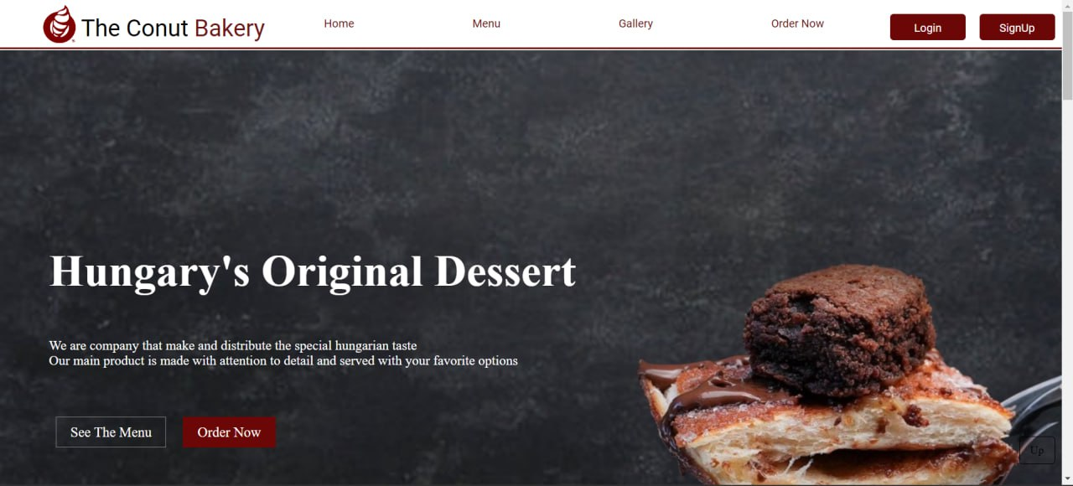

The home page of the website which the user will be directed to directly after either login, signing up, or skipping. The navbar atop the page offers smooth navigation experience for the user.

**Menu->Conut Page:**

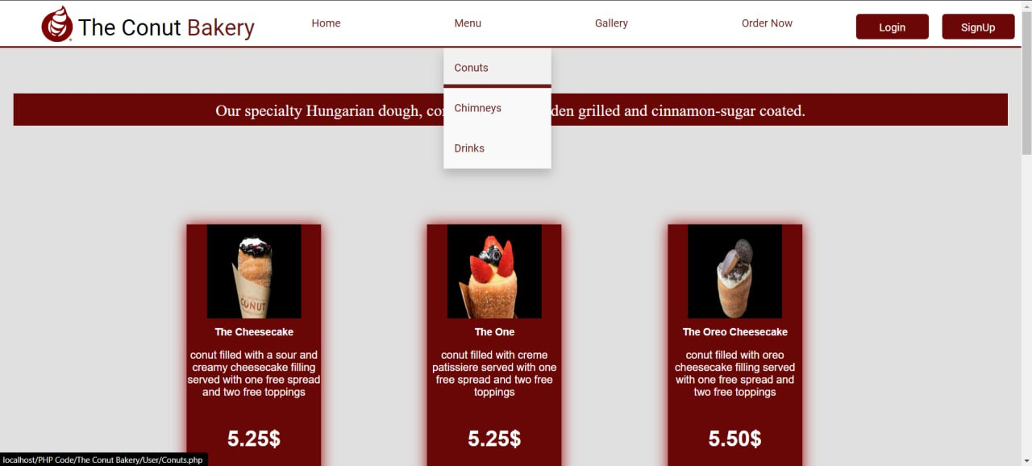

Here the user will be shown the existing type of conuts with their prices. The user can order whatever he desired and add additional toppings and spreading on each item he orders.

**Menu->Chimney Page:**

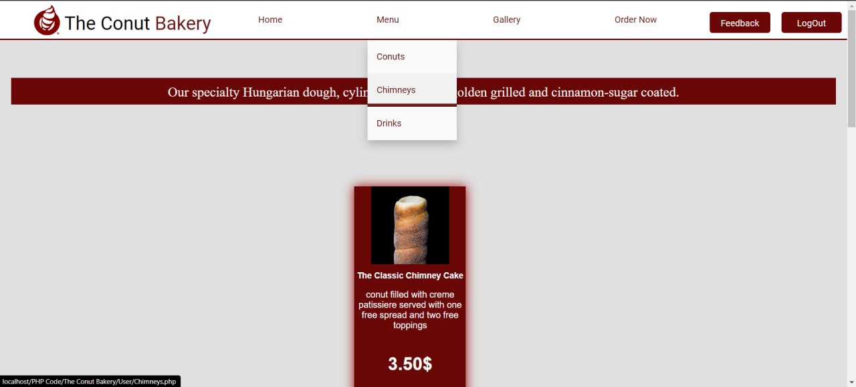

Here the user can order a chimney (there exists only one version). With toppings and spreads as well.

**Menu->Drinks Page:**

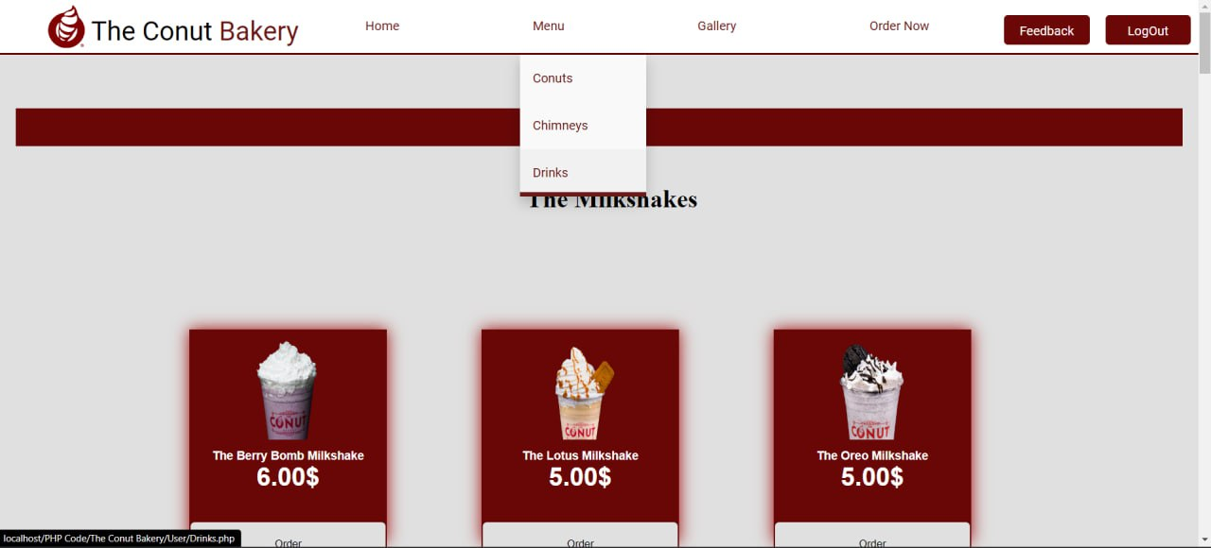

Here the user can view different kinds of drink and

In Page of the menu-pages, toppings, and spreads tables will appear:

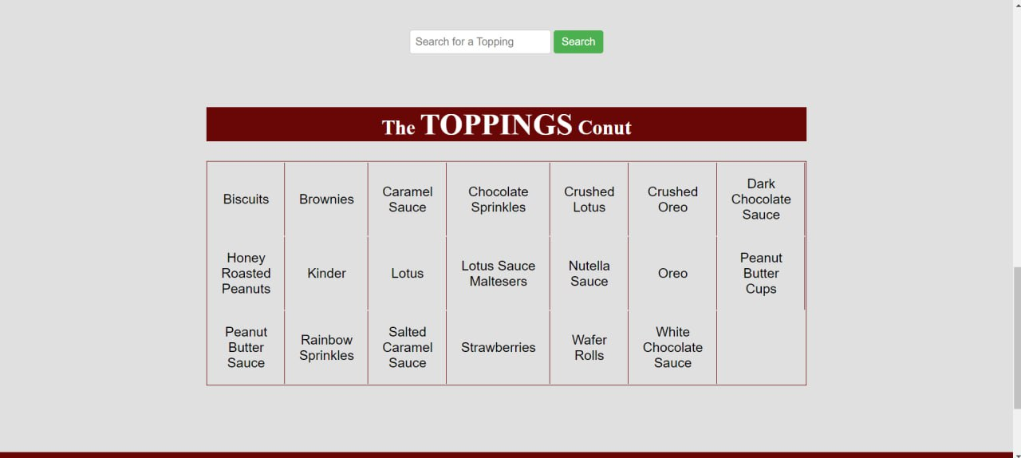

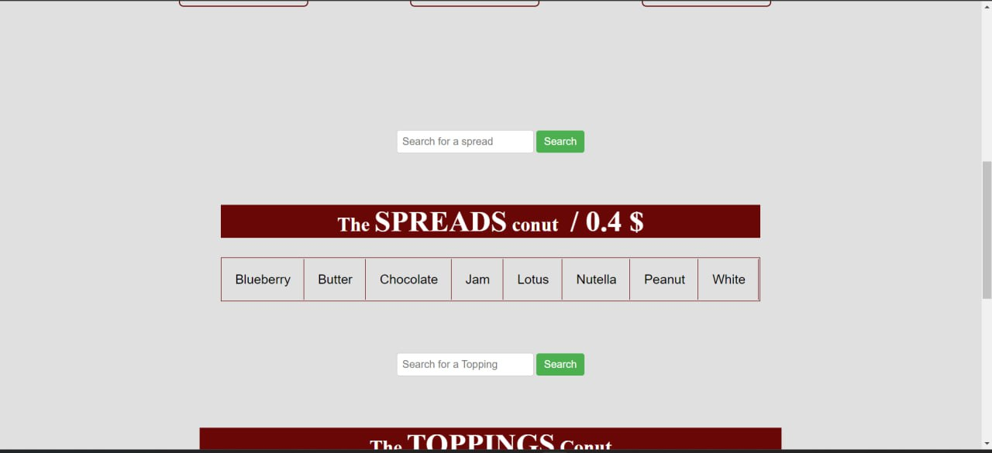The User can choose an unlimited number of toppings and spread for each item that he orders by searching for the desired spread or topping via the search bar provided above each table, and the prices will be calculated with accuracy in the “MyCard”, where the user can view what he has ordered with the affiliated additions, upon clicking close, the card gets hidden but all info is saved still, upon clicking cancel the order is deleted, and upon clicking Place an older, the order is sent to the Order Now Page:

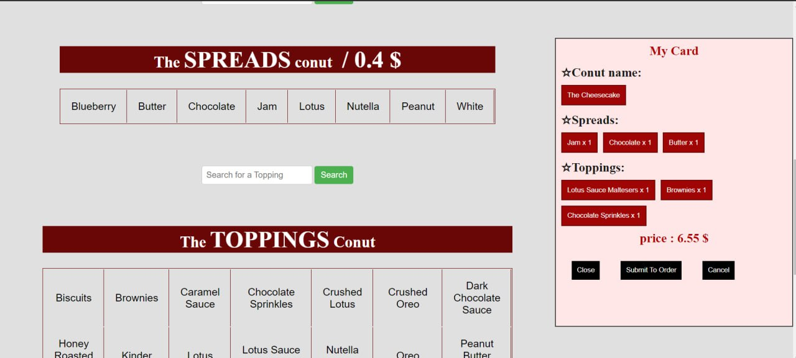

**Order Now Page:**

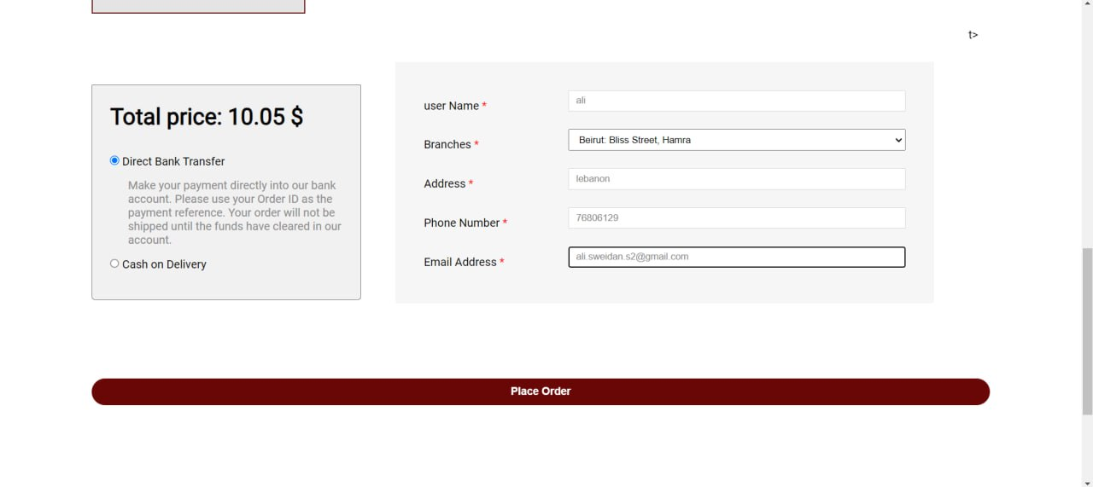

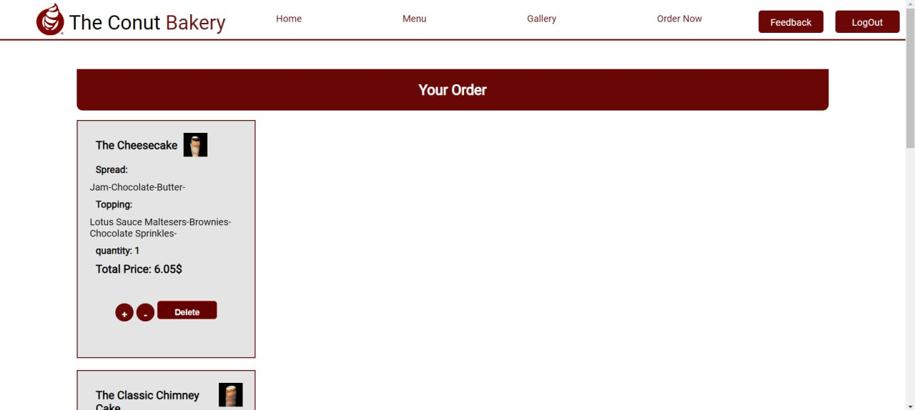

The customer can view what items he has ordered so far, and alter the desired number of each custom-made item, in each container.

**Feedback Page:**

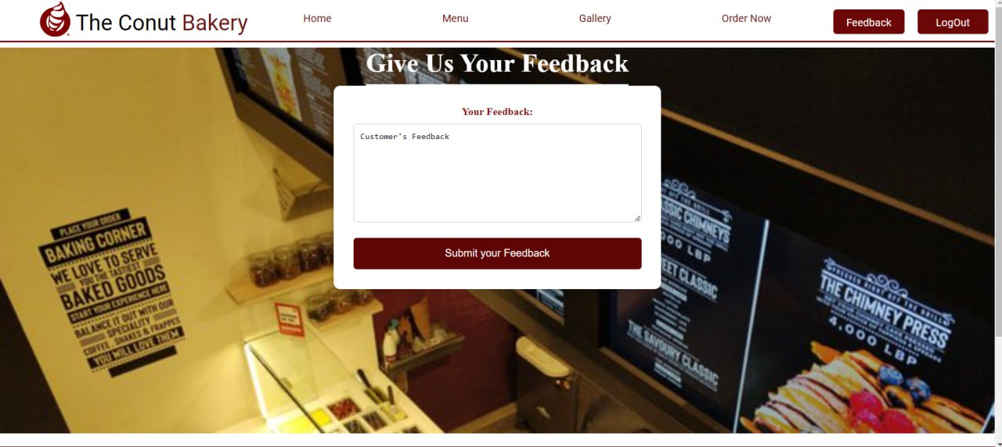

Here, the customer can write a feedback.

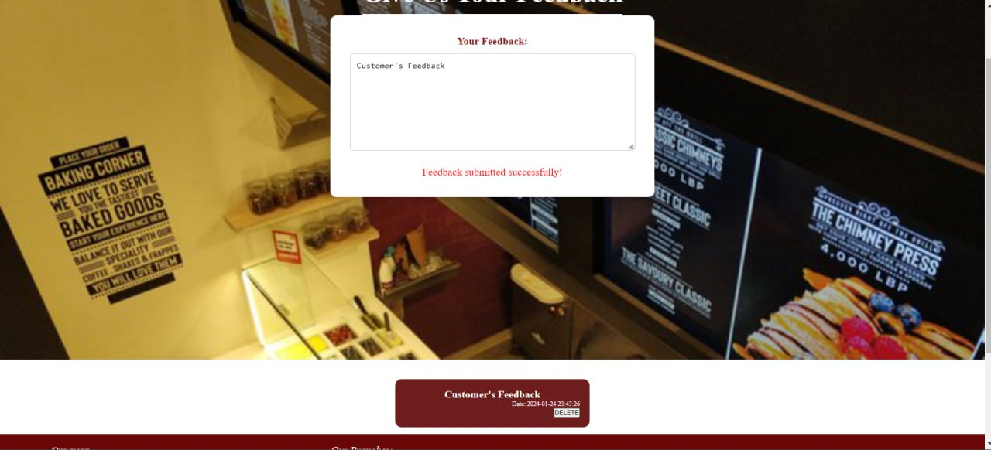

In addition to deleting his feedback only, while being able to view feedbacks from other customers.

**ADMIN’S SIDE OF THE WEBSITE**

Hello and this is the admin-side of our project, it has a unique login page different than that of the user, and it contain these following pages: “Admins”, “Offers”, “Items”, “Orders”, “History”, and “Statistics”.

Let’s start with our login page:

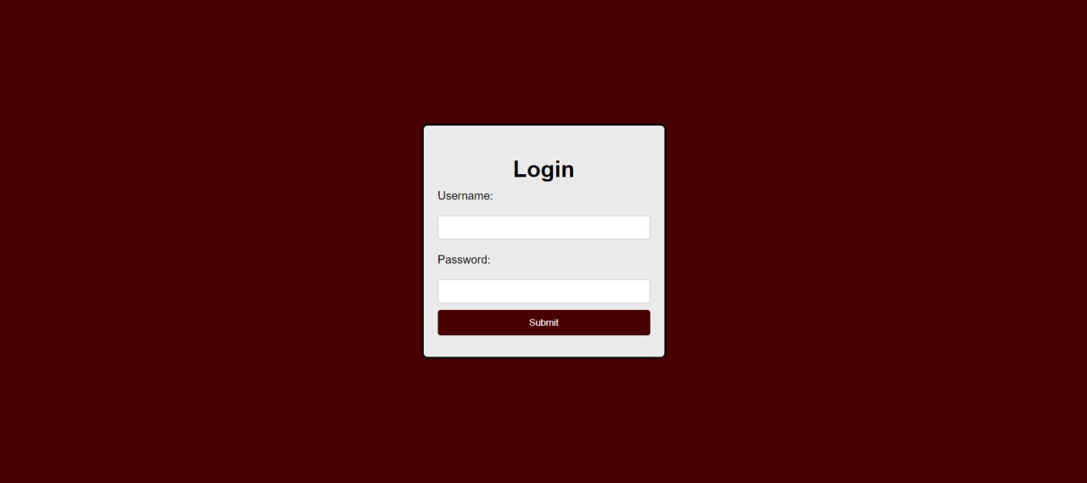

Here the admin enters the username and the password, that takes him to his page, where the big boss admin which is the “root” can add a new admin from the admin page as follows:

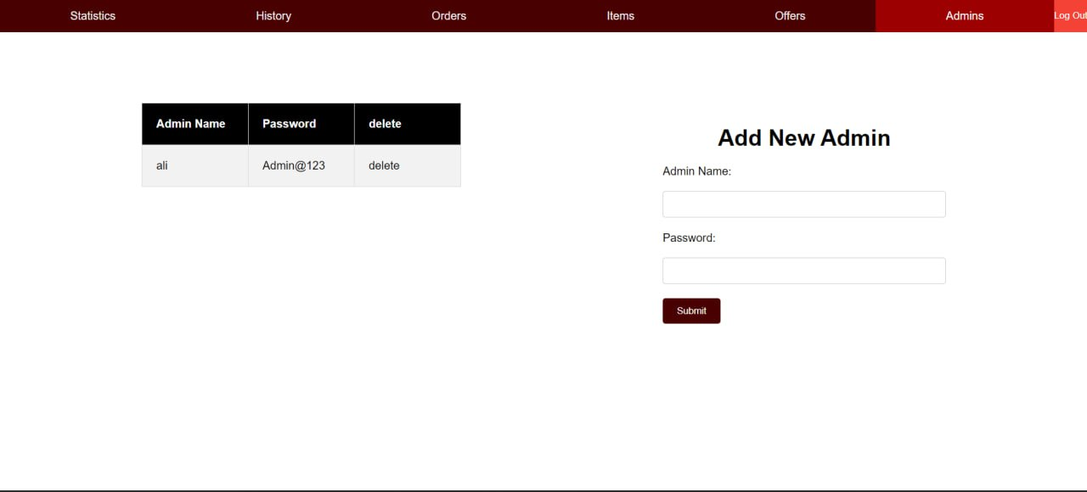

Unlike the rest of the admins that they don’t have this option.

Moving on into the second page which is the offers page:

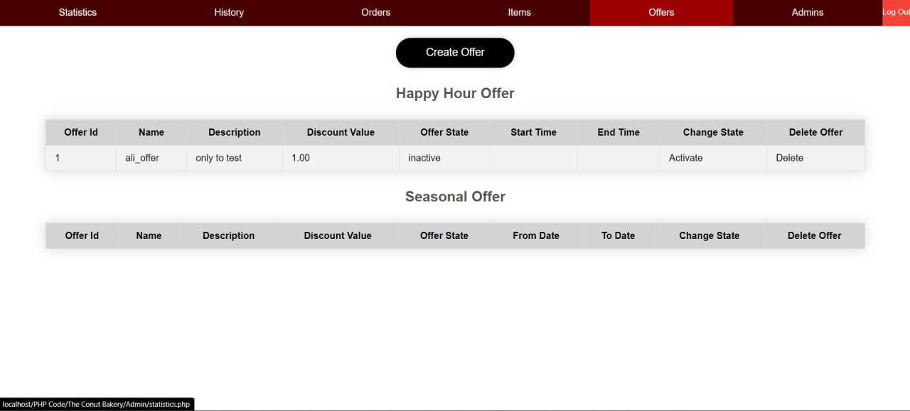

Where her the admin can create an offer between seasonal offers and happyhour offer, where he also specify the items he want to include in the offer

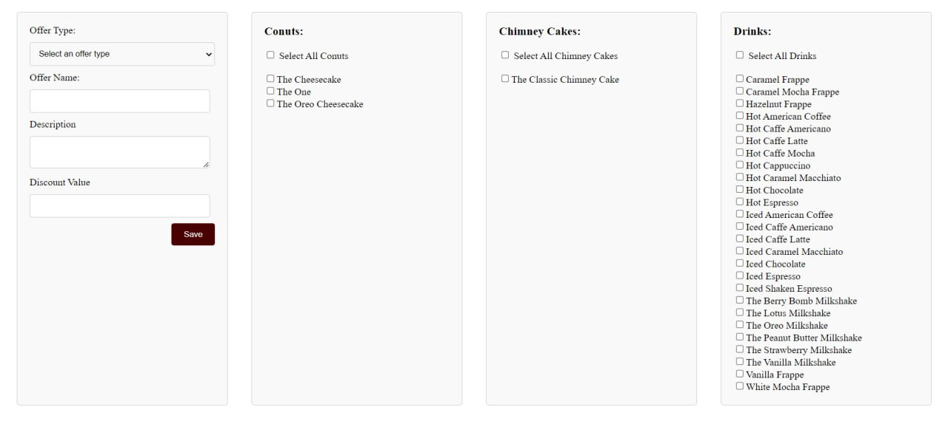

after he create the offer he will have the option to activate/deactivate it manually regardless of the start and end time specified for the offer.

However, the “Items” page is for adding/Editing/Deleting item, including the name, price , description, image and everything related to the items of the 3 categories “Conuts”, “Chiminey Cakes” and “Drinks”

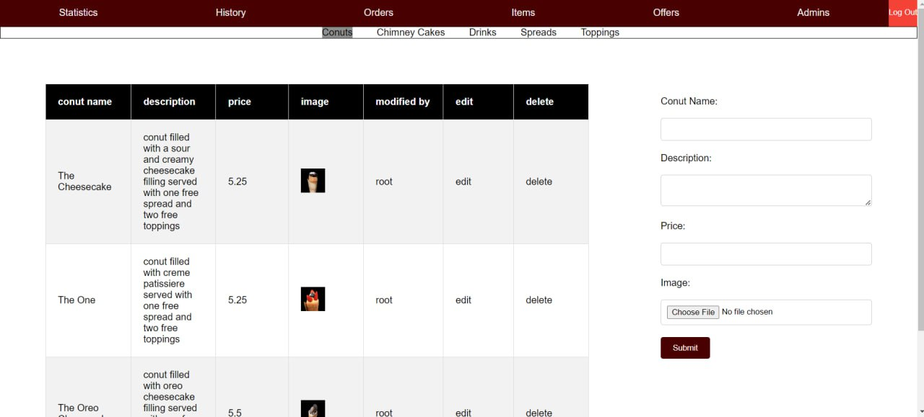

After that we have the “Orders” page which will have all the work

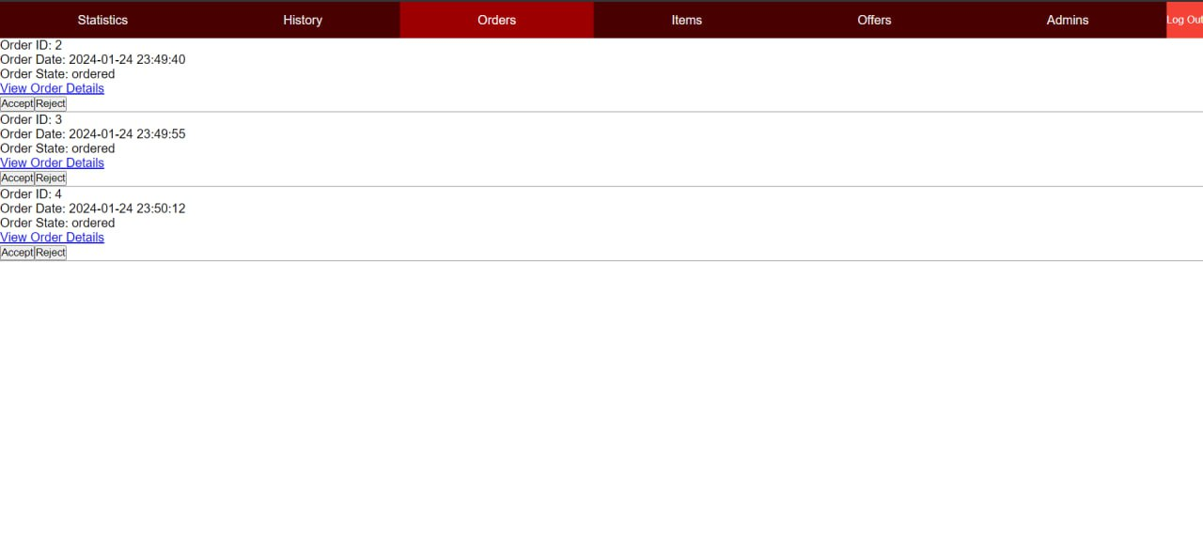

All the orders that has been ordered by the customers will be sent here to be managed, the admin can accept the order and pass it in to “in-progress” state it means that the order is getting done, and of course we can see all the order details including the customer details, after that we mark the order as done when we have finished making it.

After we mark the order as done it disappears from the orders page, and here where the role of the history page comes:

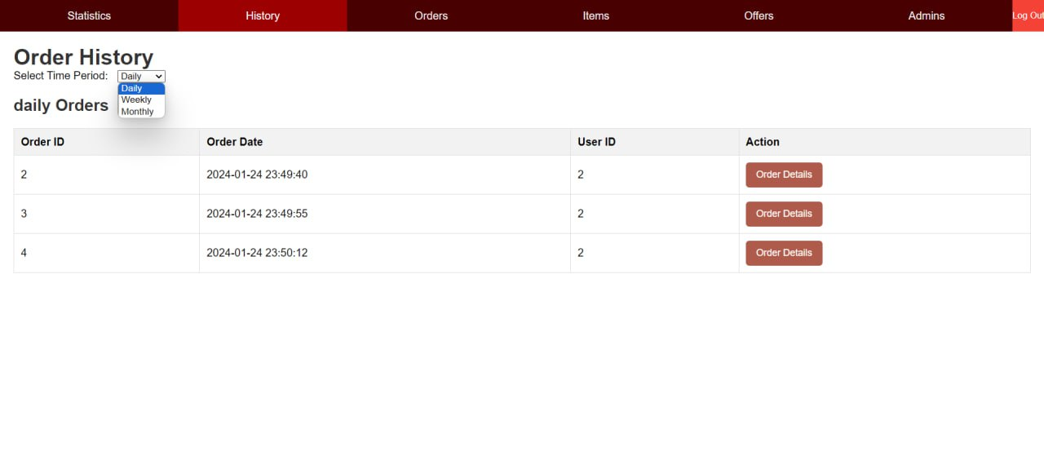

All finished orders will be passed to the “History” page and saved here for future reviewing, and we can see the daily/weekly and monthly history, and same as the orders page we can see full details of the order

Title: Statistical Analysis of Conut Chimney Drinks Sales at [The Conut Bakery] .

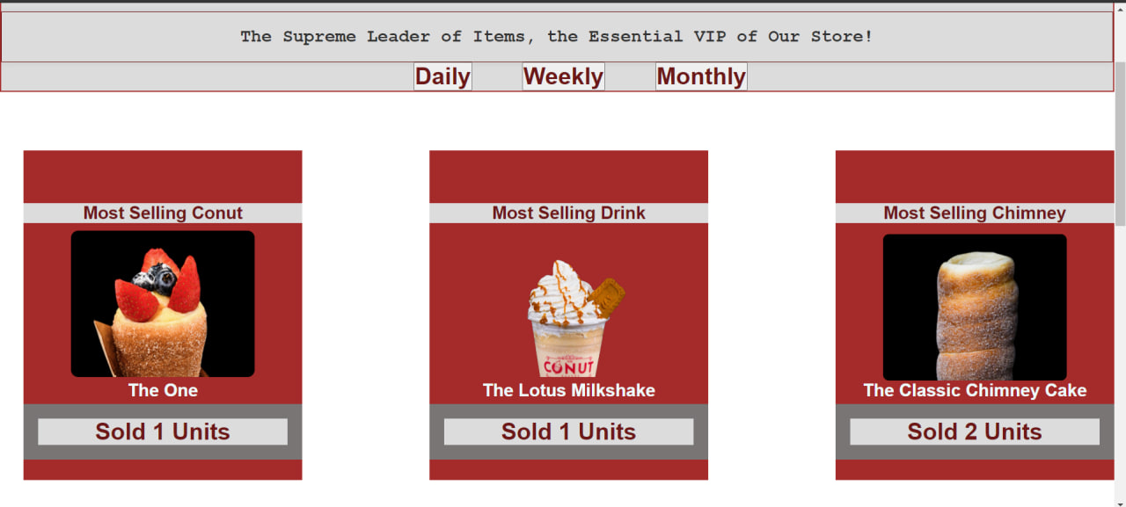

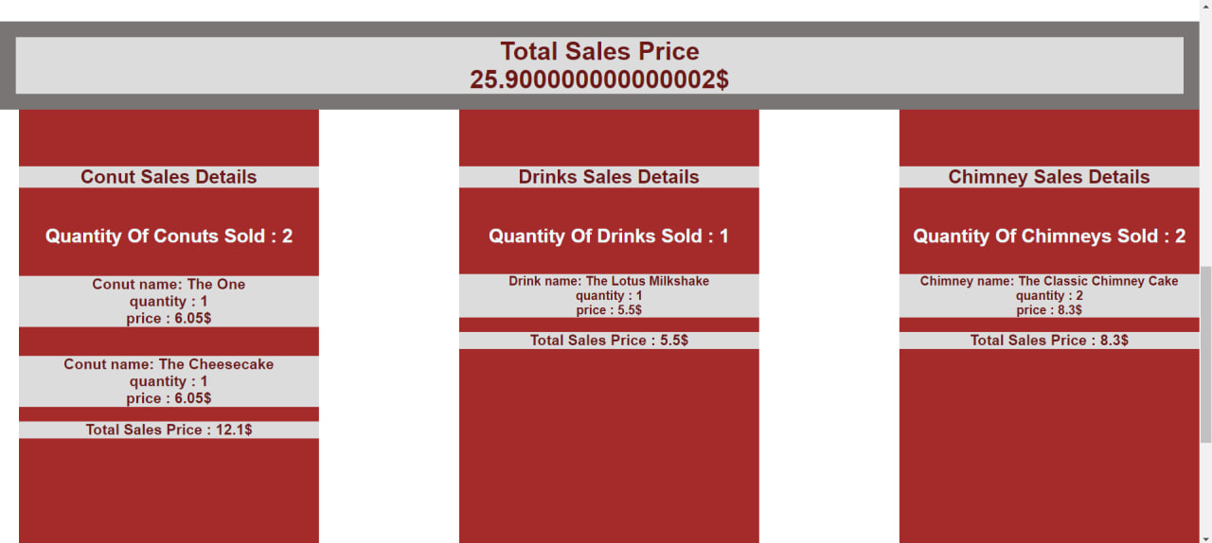

This report provides a comprehensive analysis of the sales data for conut chimney drinks at our bakery. The data is categorized into daily, weekly, and monthly sales, offering insights into customer preferences and sales trends.

Daily Sales Analysis: Our daily sales data reveals the most popular conut chimney drinks sold each day. It provides a detailed breakdown of the total sales price and the individual sales price of each item sold.

Weekly Sales Analysis: The weekly sales section offers a broader view of our sales trends. It highlights the most sold conut chimney drinks of the week and provides a summary of the total sales price and the sales price of each item sold during the week.

Monthly Sales Analysis: The monthly sales data provides an overview of our long-term sales trends. It showcases the most sold conut chimney drinks of the month and includes a comprehensive summary of the total sales price and the sales price of each item sold during the month.

Conclusion: This statistical page serves as a valuable tool for understanding our sales trends and customer preferences. It allows us to make informed decisions about our product offerings and pricing strategies. Furthermore, it provides essential information to the person responsible for finances and staff management, enabling them to assess our daily, weekly, and monthly achievements in sales. This data-driven approach ensures transparency and aids in effective decision-making for the bakery’s growth and success.